Worcester News

'There's no conflict between science and faith'
6:20am Thursday 23rd February 2012
By Tarik Al Rasheed
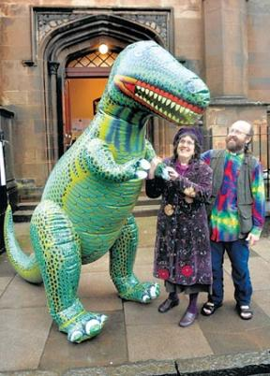Evolutionary theory: The Rev David Coleman and his wife Zam Walker, ministers of Greenock United Reformed Church, with their dinosaur ‘Reverend Green’. The Rev Coleman will speak at the Malvern Evolution Weekend.
A SCIENCE and faith event celebrating Charles Darwin and his contribution to evolutionary theory will be taking place in Malvern next month.
Malvern Evolution Weekend will comprise a series of events in venues around the town on Saturday and Sunday, March 3-4.
Malvern played an important part in Darwin’s life. He came to the town for treatment after developing a fever during his voyage on HMS Beagle, and it was also the place where he brought his 10-year-old daughter Annie in the hope that she would benefit from the famous Malvern Cold Water Cure. She is buried in Great Malvern Priory having died on April 23, 1851.
Malvern Evolution Weekend will begin on March 3 with two free presentations by Prof Mark Pallen at the Malvern St James Drama Centre in Avenue Road.
The first, at 2pm, is entitled A Rough Guide to Darwin and the second, at 3.30pm, Evolution: Evidence and Ideas.
At 7.30pm that evening, the Rev David Coleman will lead a multimedia evening entitled A Time of Wonder at St Matthias in Church Road.

Then, at 11am the following morning, he will lead a ‘Dinosaur Sunday’ service at Holly Mount URC in Queens Drive.
The weekend will also incorporate a children’s activity morning exploring the world of fossils, rocks and minerals.
This takes place at Holly Mount URC between 10am and noon on March 3, and is being supported by Museums Worcestershire and Herefordshire and Worcestershire Earth Heritage Trust.
Organiser Andrew Webb said the weekend was one of many taking place worldwide as part of Evolution Weekend 2012.
“Although there have been a few events associated with Evolution Weekend, this is the first time we’ve done a full programme like this in Malvern,” he said. “It’s really to celebrate science and faith and the fact that there is no conflict between them.”
For more information on the weekend, call 01684 565708 or e-mail info@ malvernevolutionweekend.org. uk, or for ticket information e-mail tickets@ malvernevolutionweekend.org.uk.
Booking is essential for the presentations at Malvern St James.

